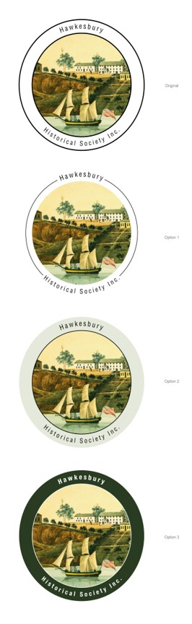

Bulletin of the

Hawkesbury Historical Society

No. 2, May 2020

FROM THE PRESIDENT

I guess by now our Hawkesbury Historical members are more scattered in their current responses to COVID-19 than when I last wrote two months ago, as some businesses, schools and public venues tentatively re-open. Museums too are moving in this direction. Yet the fact remains that the uncertainty is still real for many of our members and duty of care is dictating our responses still as a Society. There will be no change at present to HHS’s current mode of operating through this Bulletin and the Newsletter only. I shall convene an audio-visual committee meeting in July to look further at the issue and re-evaluate then on the situation as it has progressed. I find I am missing our face-to face meetings, but I have plenty to keep me busy.

I hope everyone of you are staying busy and well in the meantime.

What a shame we have had to temporarily lose our local papers. It is really something I hope will be just for now, but nonetheless in the lull we are no longer calling for historical articles of 480 words. Do feel free, however, to keep writing and stock piling them, and please see Jan Readford’s note about needing Newsletter contributions later in this Bulletin.

Please stay in touch with the Committee and each other and feel free to correspond with the contributors to this Bulletin should you wish to. We should love to hear from you.

Jan Barkley-Jack

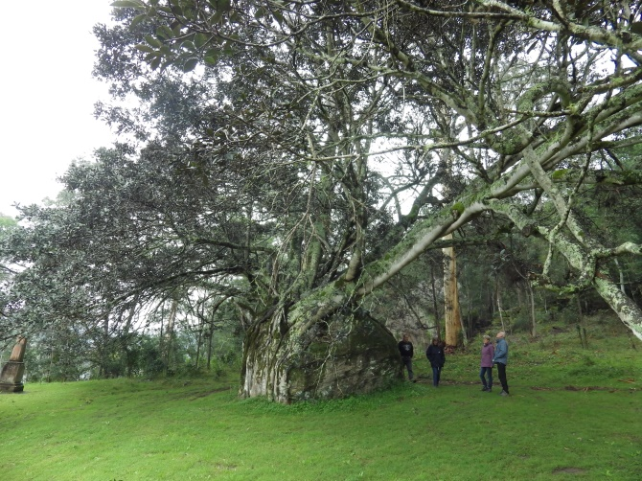

**The Fig tree**

**at the Sackville**

**Aboriginal Mission amazingly growing over an enormous rock, its roots**

**encapsulating the entire rock**

**which is twice as high as**

**a human.**

**Question: Did you know that Windsor is about to lose forever its 1874 bridge?**

Several reports recently prepared by highly qualified engineers attest to the fact that the bridge is completely safe and will stand for many years to come, yet Traffic for New South Wales [RMS] are determined to pull our historic bridge down now the new bridge over the Hawkesbury River at Windsor is opened to traffic. **Image how wonderful the old bridge could be if made available for visitors to saunter across and to view the river from its centre**? Please contact RMS today if you disagree with its removal. TIME IS RUNNING OUT.

**?**

**?**

**?**

**?**

**Items of interest received this month by the Secretary**

**what correspondence has been about?**

**notifications etc.**

**FIRSTS IN THE HAWKESBURY…**

In 1869 Windsor volunteer flood brigade was formed- the first in Australia. The government provided four boats and other brigades around the Hawkesbury soon followed. *The Sydney Mail and NSW Advertiser*, 6 May 1871, reported: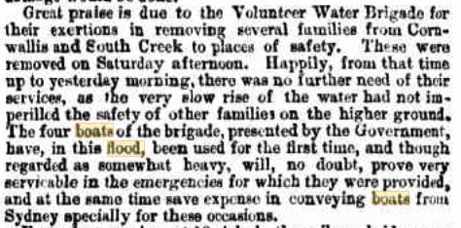, reported.

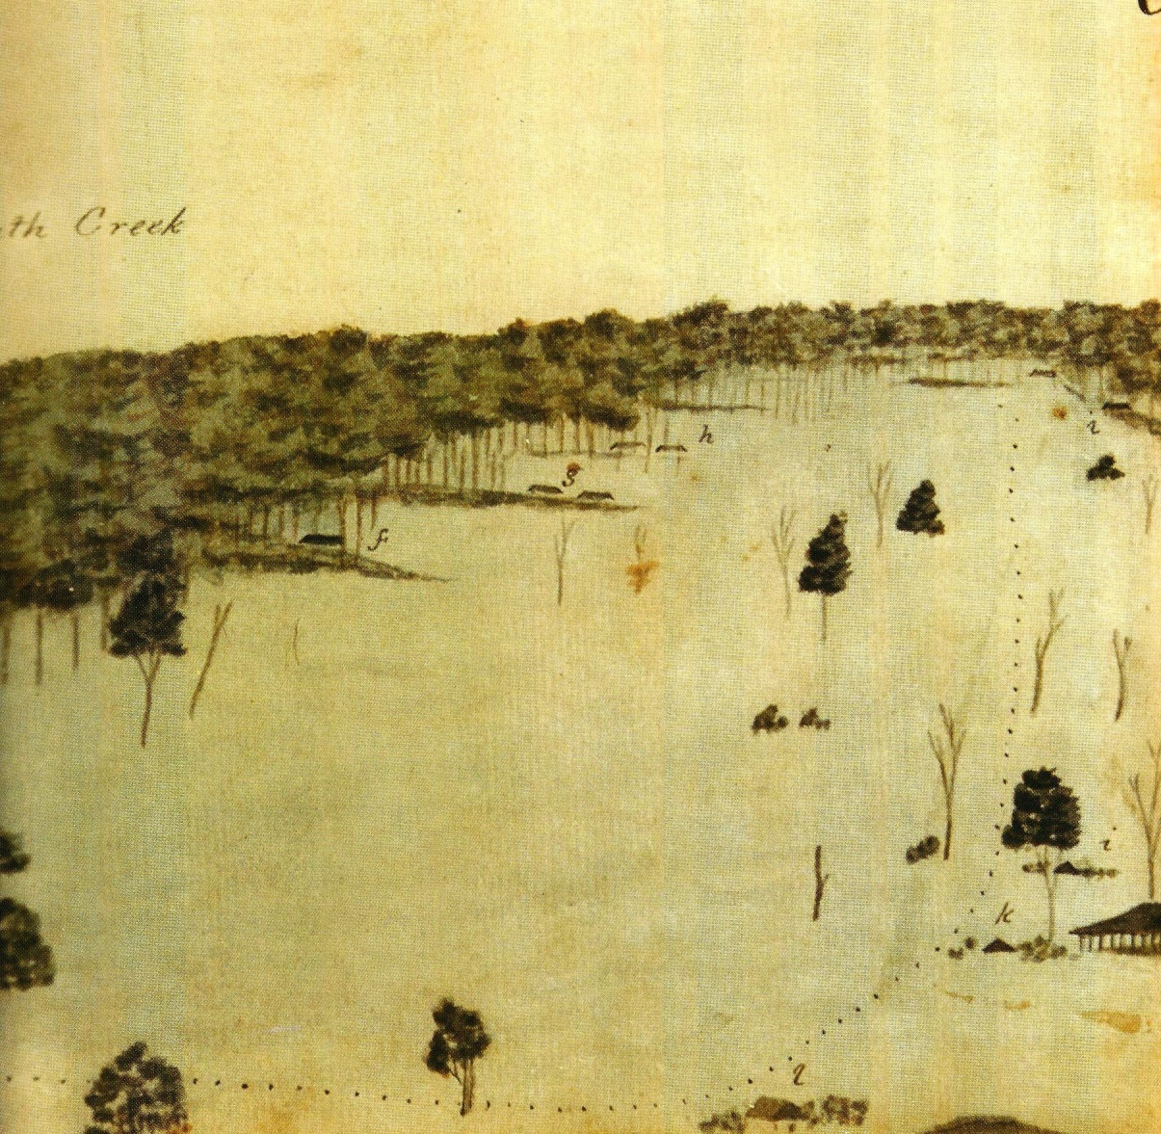

Illustration: Detail from the ‘Sketch of the inundation in the neighbourhood of Windsor…2 June 1816’, Mitchell Library PX*D264.

**FROM THE NEWSLETTER EDITOR**

A SMALL RESEARCH PROJECT FOR THOSE LOOKING TO KEEP BUSY AT HOME:

Hawkesbury Historical Society is still planning to hold another if its ‘the true story’ historical tours when events return to normal, following the success of last year’s popular tour organised with the wonderful help of Robyn and Penelope Sharpe around Margaret Catchpole. When it becomes possible, the next tour will be about the life and legend of the **Bushranger Thunderbolt** who was born in the Hawkesbury district as Fred Ward, and was educated here at Wilberforce. As little historical background is known about his early life, it would be helpful for anyone interested to start collecting information from trove and elsewhere in preparation for the tour. Any information would be valued….thanks Jan.

**Notice re: Biographical Database of Australia (BDA) –**

**a Non Profit Project Advanced Search facility available on line**

**Search ‘BDA online’**

**This is a wonderful facility for those researching early Hawkesbury families or individuals, and is quite cheap to join. Carol Liston, whom many of you will know, has put out a plea:**

‘We need your help. An Advanced Search facility on BDA will significantly increase its usefulness but programming for the project will cost about $30,000. This amount is beyond the revenue generated from subscription income. The individual annual subscription rate has remained low to encourage support from genealogists and historians for this non-profit project…BDA receives no government financial assistance. Would you consider making a tax deductible donation to make possible the achievement of Advanced Search in 2020?...Payment can be made by:  
bank transfer to CBA BSB: 062438 account number: 1013 9326 ref your name, or  
by cheque made out to BDA Library Inc. posted to PO BOX 795, North Sydney 2059.  
Receipts will be issued by BDA under the Tax Assessment Act 1997. Any amount of $2.00 or more is tax deductible.’  
Carol Liston AO  
Board Chair

A note from the Treasurer/ Book Sales Report: Heather Gillard

Book Sales to 27Mar $7636.70 Cost $4931.60 Profit $2705.10 Museum received $1207.74

Net profit on book sales to HHS $1,497.36

Assets 3 T/D’s $16,000 Book Stock $9856.21 Operating Bank Funds $2455.83 Total $29312

Profit & Loss to March 31 $1247.11 Note Interest only $223.50 due to the Pandemic

What’s happening with the website: Dick Gillard

The web site can be accessed on Google or Google Chrome by typing in: -

[**www.hawkesburyhistoricalsociety.org**](http://www.hawkesburyhistoricalsociety.org)

The web site does not appear to be accessible via Firefox. If you don’t have Google, you can download a free copy direct from Google. If you have a problem email me at : -[gillardrh@bigpond.com](mailto:gillardrh@bigpond.com).

All newsletters from April 2018 are now on the web site along with all books available for sale.

Don’t’ forget our Facebook page: Peta Sharpley

Metters certainly manufactured a diverse range of products!

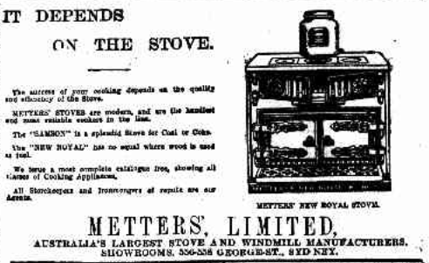

**WORDS:** **To find the context of this phrase see**TROVE NEWSPAPERS, *Windsor Express and RichmondAdvertiser*, 17 May 1843, p. 2.